
MERU UNIVERSITY OF SCIENCE AND TECHNOLOGY
DEPARTMENT OF ELECTRICAL AND ELECTRONICS ENGINEERING

BACHELOR OF TECHNOLOGY IN ELECTRICTRAL AND ELECTRONIS ENGINEERING

TITLE: LAB REPORT: Traffic Control System Simulation Using Intel 8085 Microprocessor (Assembly Language)
https://github.com/joshuamuthenya/microprocessors.git

NAME: JOSHUA MUTHENYA WAMBUA
REG NO: EG209/109705/22
UNIT CODE: 3400
DESCRIPTION: MICROPROCESSOR ARCHITECTURE AND INTERFACING
DATE:05/12/2025

Introduction
https://github.com/joshuamuthenya/microprocessors.git

Objectives

Softwares/Kits used.

Procedure

https://github.com/joshuamuthenya/microprocessors.git

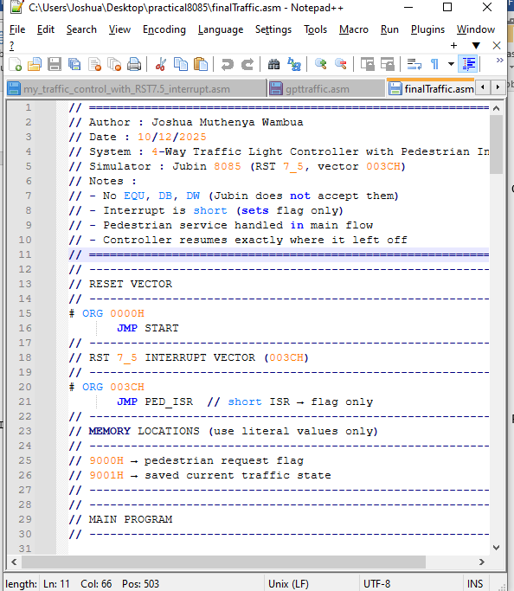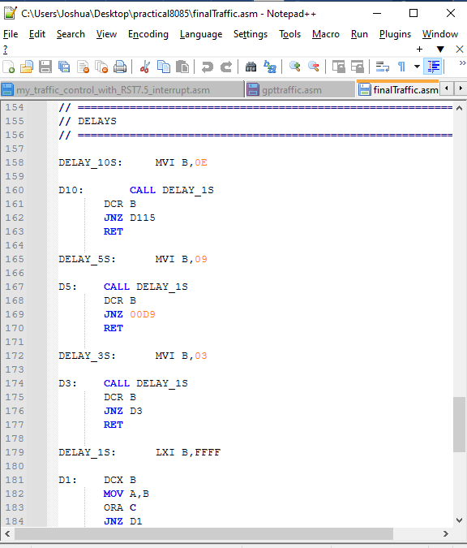

Results

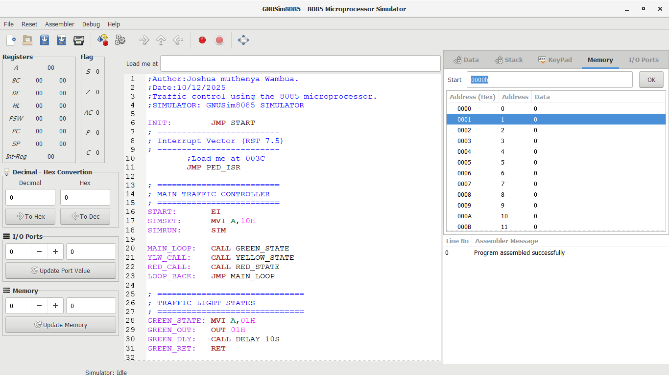

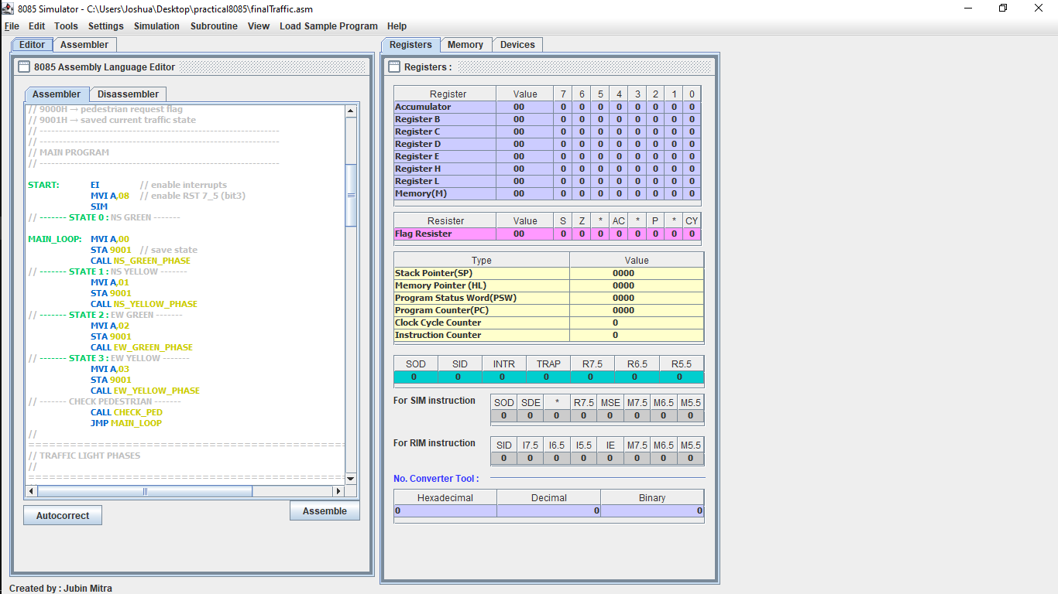

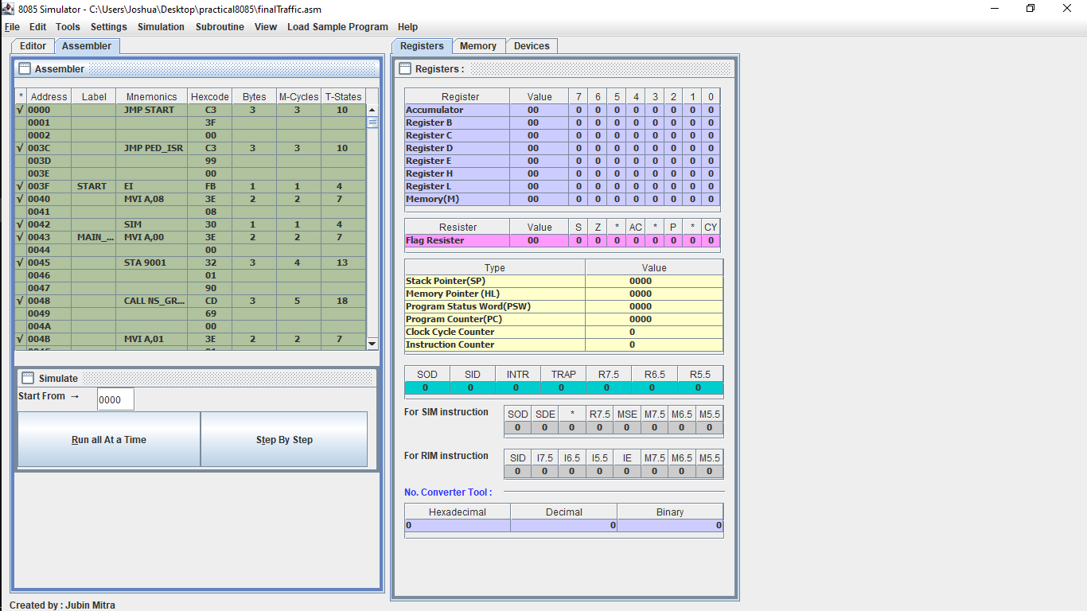
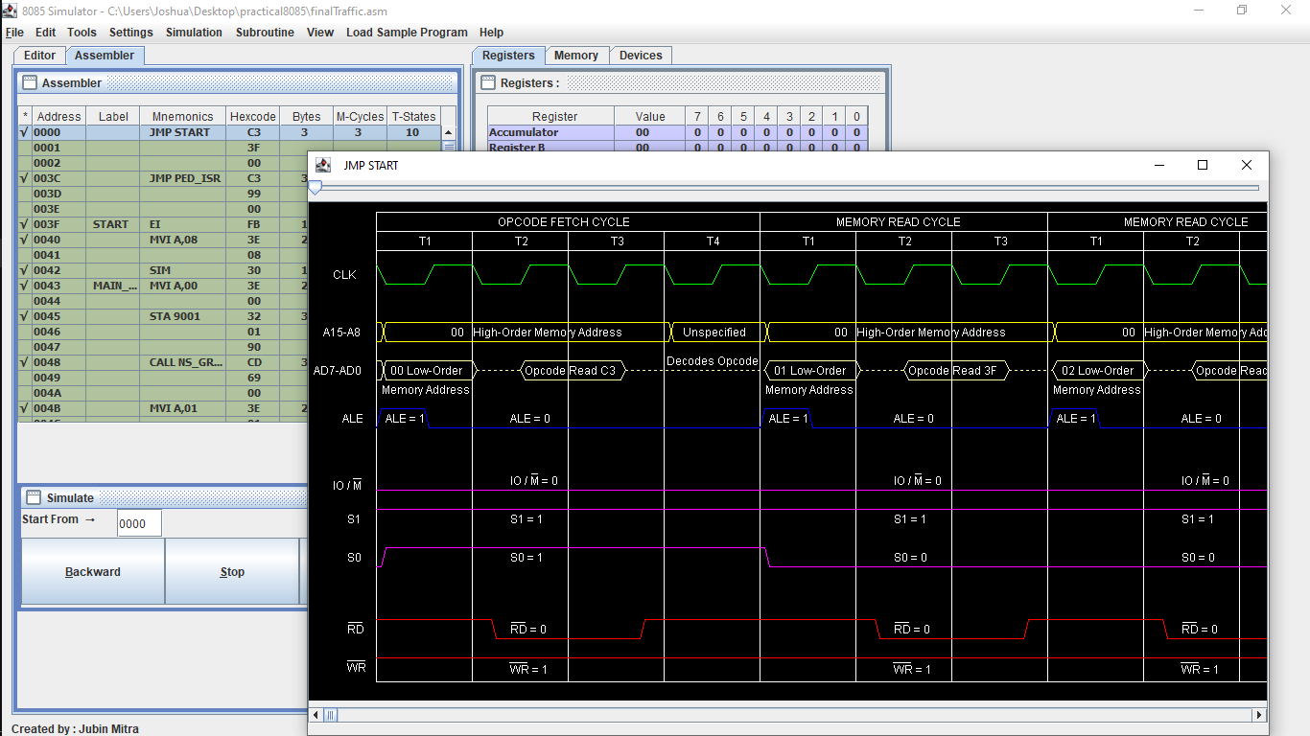

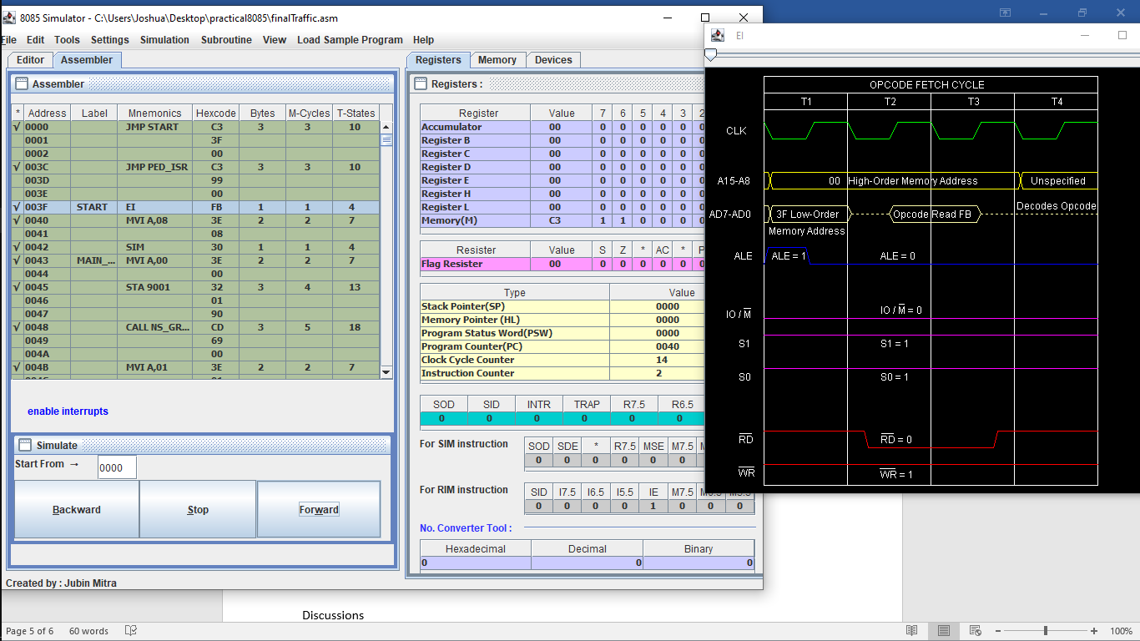
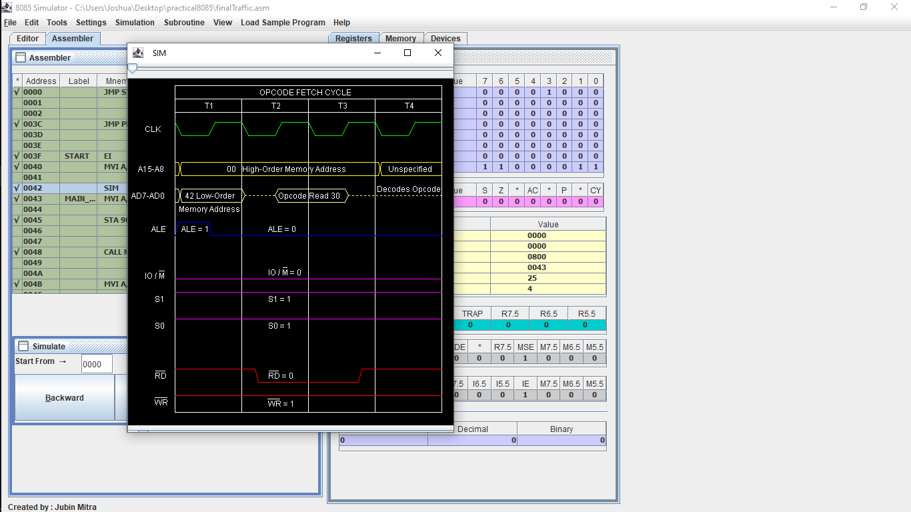

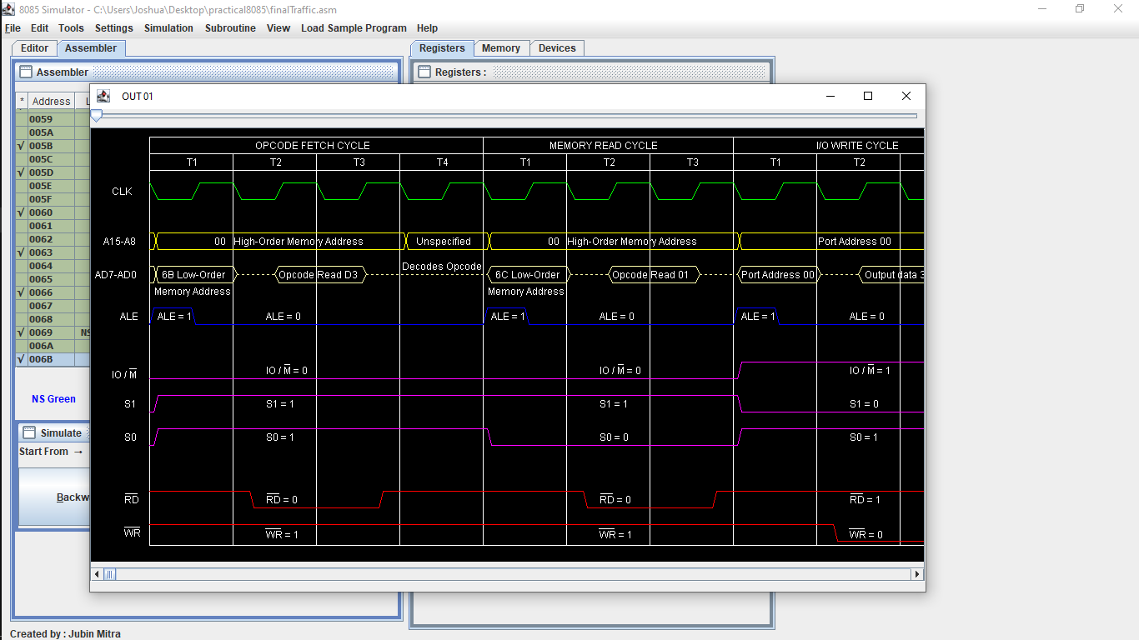

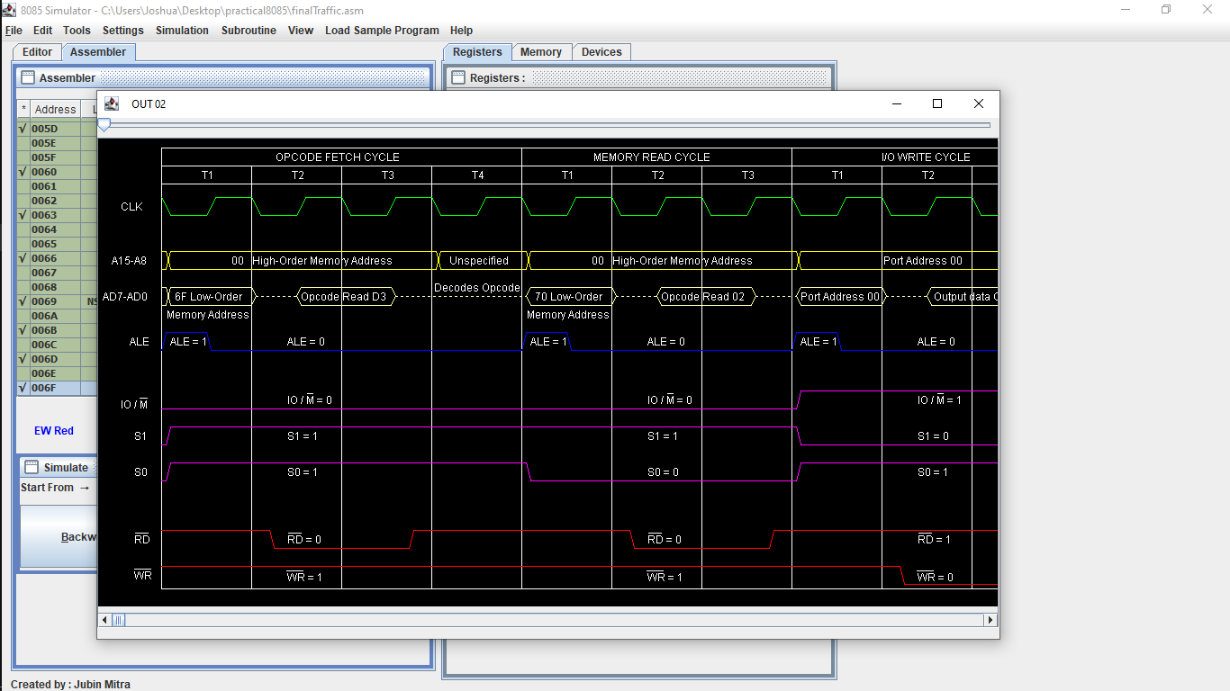

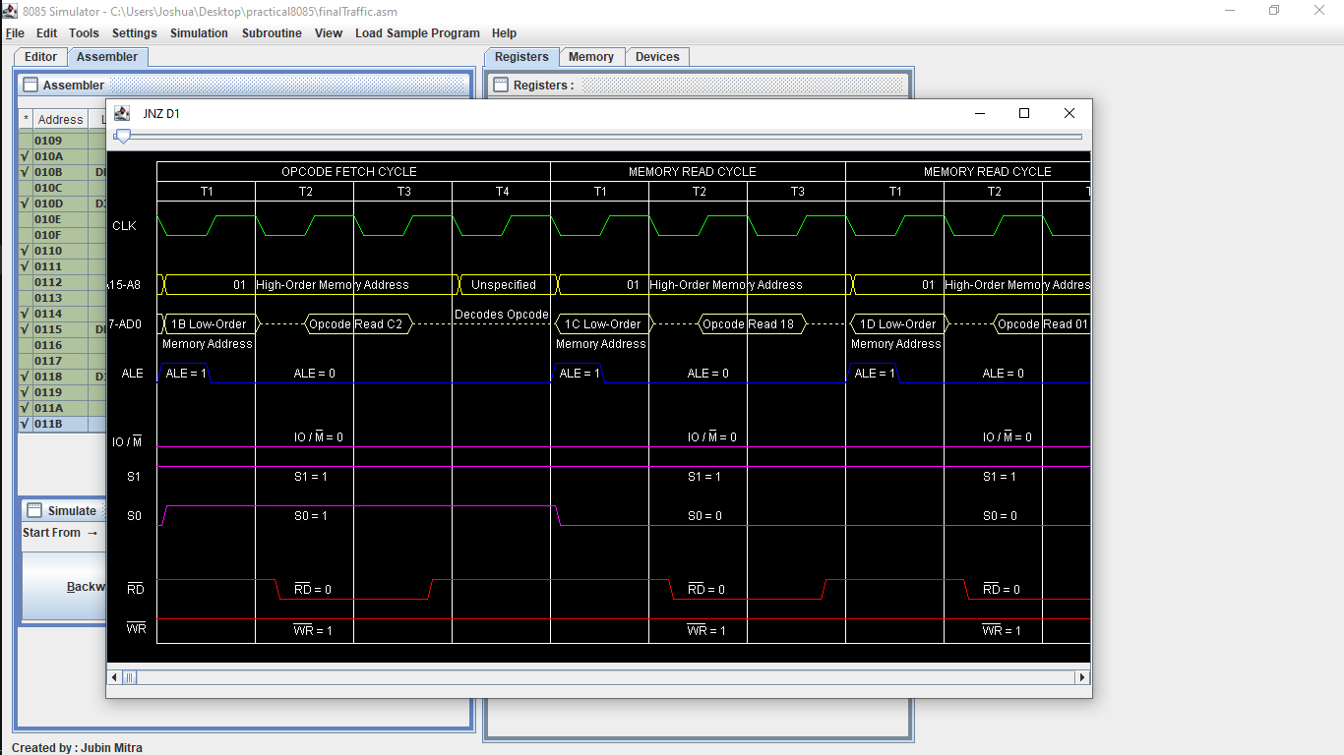

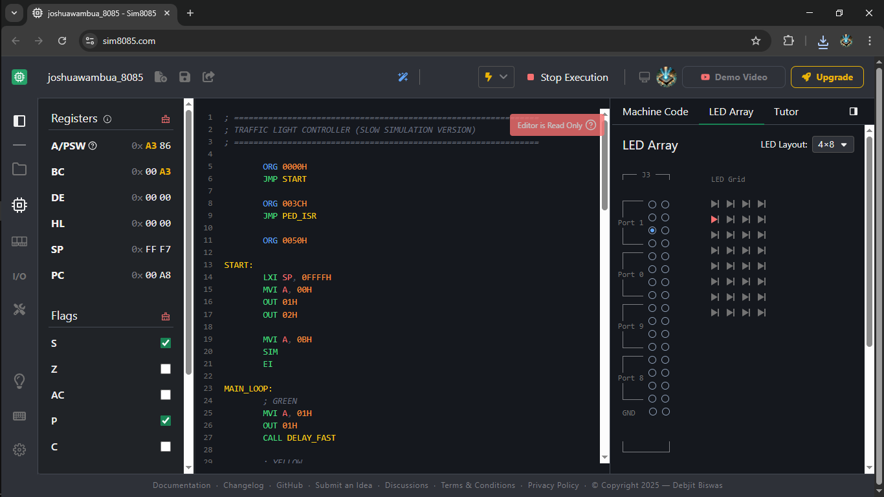

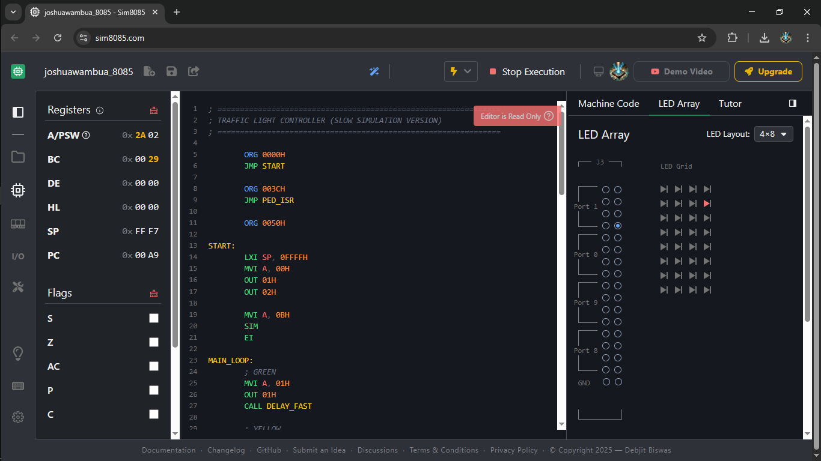

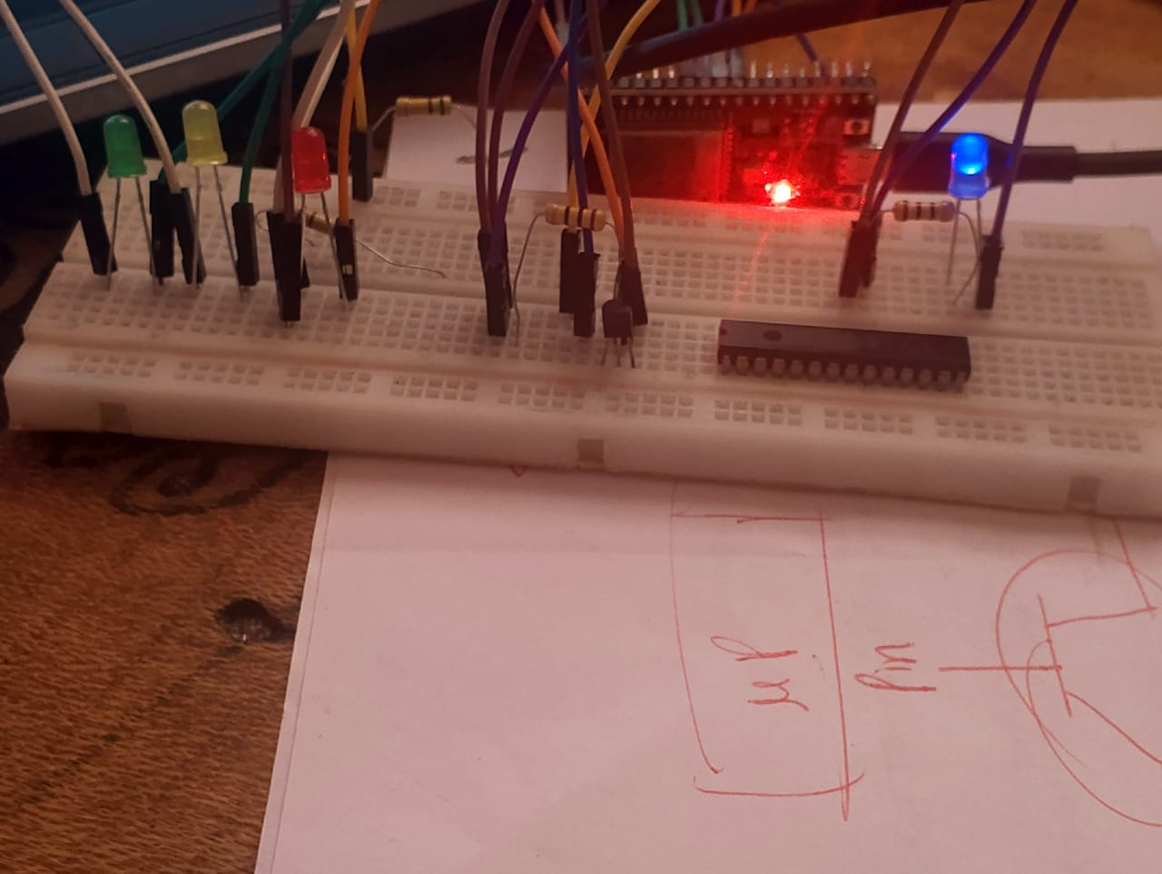
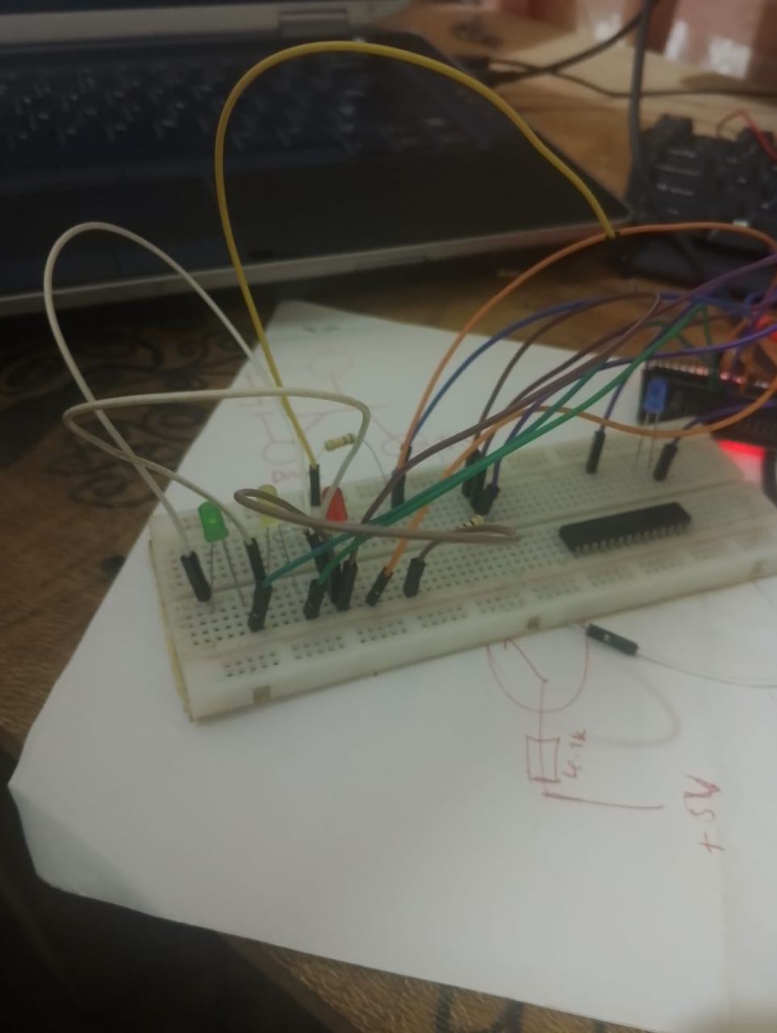
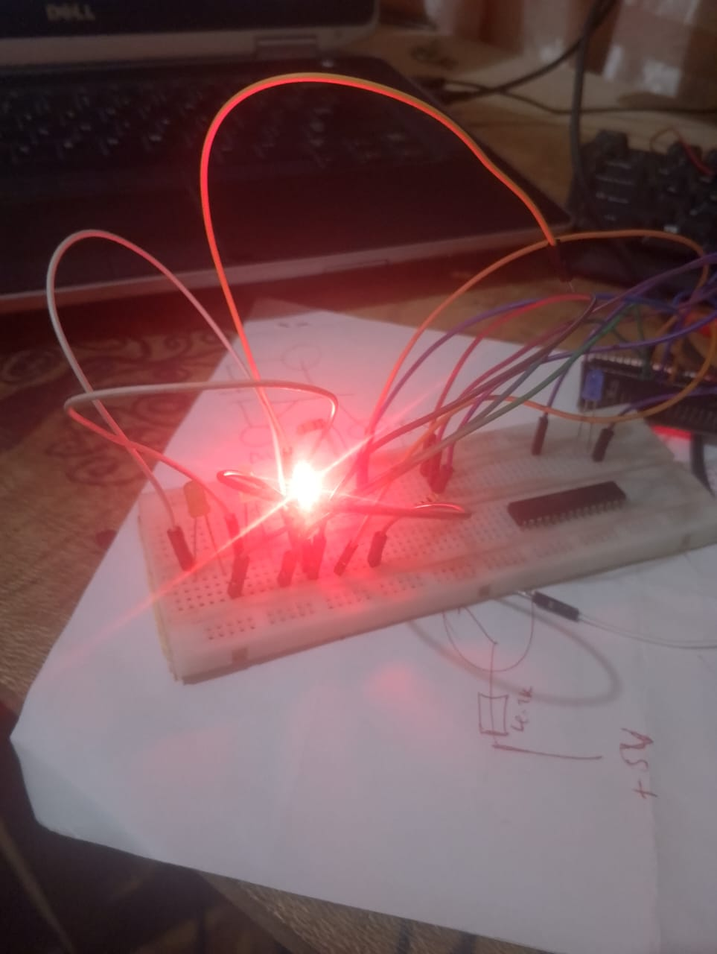
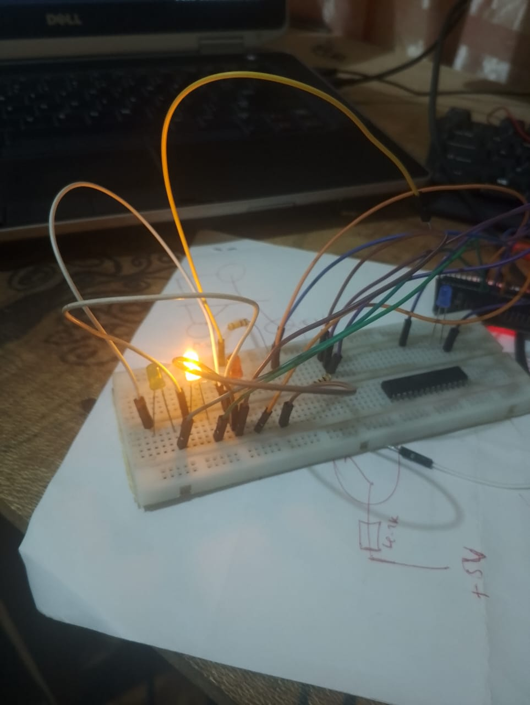

Discussions

Conclusion

References

